**Analysis of survey answers given by males**

# **Statistics – Question 1**

### *What do you consider to be commonsense knowledge when washing clothes?*

Empty all pockets.

Separate you clothes by color. For example: Colored, dark and white separately.

Kleur op kleur. Zwart op zwart. Kleren van binnenuit wassen voor optimaal resultaat.

Kleren in de trommel doen, deurtje dicht.

Not too hot, seperate colors from white, use the right type of detergent per specified wash.

Which types of clothes can be washed together, and the functions of different programmes

1) Seperating colours.

2) using the right temperature.

Wash white with whites only.

Separate colored and white clothes, and separate different clothing materials.

Opening door.

Knowing that you don't wash white and colour together.

Seperating colors, using detergent

Use soap. Let it dry in the sun immediately after you’re done.

In case of washing your clothes with a machine, I think the buttons of how long you want your clothes to be washed and how f.e. Handwash mode.

Kleur scheiden, bepaalde temperatuur, poeder erin, vergeet je telefoon niet eruit te halen

All the clothes are wet after it's washed.

It will take some time till the clothes are dry.

You have to open the clothes, so it can dry faster.

You have different kind of standards for washing the clothes. For example colourful clothes and white clothes.

Turn around socks.

Color correct.

Divide between coloured and non-coloured clothes.

Seperating colors and fabrics.

Witte was en gekleurde was apart wassen.

Watch the labels, colors, temperature and materials.

sorting by colour, clothes having washing / drying instructions on the labels

-At which temperature you wash specific pieces of clothing.

-Washing colour-organized.

Seperating the whites from the colours.

Set the machine ,hang the clothes,fold them.

Separate white from colour / Where to put softener.

Kleuren scheiden, wasmachine aanzetten.

Degrees and putting white with white only.

Knowing how to sort clothes, what detergent to use and when to apply fabric softener.

Bedienen van wasmachine.

What temperature to use, what colors not to combine.

Washing clothes means they are dirty.

Water is required to clean clothes.

A washing machine can be used to wash clothes.

you need soap and water.

- A too high temperature will damage coloured (mostly cotton) clothes.

- New coloured clothes can release colour and affect other clothes they're washed with.

- Soap is required.

- Conditioner can be used.

- Use spin dryer to make your clothes dry faster.

- Spin dryer can damage delicate clothes.

- Wool stuff shouldn't go in the washing machine.

- Choose the temperature and the time according to the type of clothes you're washing.

It involves warm water, detergent, clothing, dirt or stains in them. You wash using a laundry machine. It takes electricity to spin the clothing through the warm water, where the detergent dissolved in the water dissolves the stains. The clothes are spun at high speeds at the end of the washing cycle to spin out the water, but the clothes emerge damp from the machine, so you need to dry them out.

Clothes need to be removed from the machine once washed.

the laundry will be washed, but comes out wet, and will need to be hung out to dry afterwards.

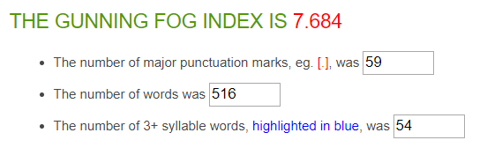

|  |  |
| --- | --- |
| Average Word Length (char) | 5.1 |
| Average Sentence Length (word) | 7.4 |
| Monosyllabic Words (1 syllable) | 264 |
| Polysyllabic Words (≥3 syllables) | 81 |

**69 sentences in total**

**37 answers in total**

**On average: 1.9 sentences per answer, with a sentence length of 7.4 words per sentence.**

# **Statistics – Question 2**

### *What do you consider to be commonsense knowledge when doing dishes?*

Scrub it well, more than once, until clean.

Rinse the dishes, then use soap to clean and finally wash it off. Also use hot/warm water, not cold.

Het gebruik van een spons bij het wassen van de borden, lepels, etc. wanneer men niet gebruik maakt van een vaatwasser.

Schoonmaken.

Use soap, hot water, dishwash soap.

When using a dishwasher, you should know how the dishwasher functions and which items can be put in the dishwasher.

When doing the dishes without a dishwasher, you should know what type of cleaning product to use.

Not using the same sponge you use for washing cutting boards where you cut raw meat for regular utensils.

Use Hot water.

Opening tap.

hoe je de vaat wast.

Use hot water.

The use of soap and clean both sides.

Where the dishwasher tablet should be put. Whether you wash it by hand or the dishwasher, you need water.

Gebruik zeep, heet water, niet tegen de antiaanbak laag.

You can do the dishes by hand and also with a dishwasher.

It will dry when you clean it with a dish towel.

You need soap and water for the dishes, otherwise it will not be clean.

Washing properly.

Use dish soap. Rinse the dirt off with water.

Afwas zo zetten dat het kan opdrogen.

De manier hoe je schoonmaakt.

That you should put soap in, use a brush, then dry it after.

using soap and some kind of spunge or brush.

Clean your dishwasher one time a month.

Hot water more effective.

Use warm water.

Afwasmiddel en een sponsje gebruiken op z'n minst, vaatwasser inruimen.

All the dishes have to be clean and they have to shine.

Borden.

When to apply different kinds of sponges and how to use water temperature to your advantage.

Hygiënisch zijn.

Use warm water and soap.

Use high temperature for greasy dishes.

Soak dishes and pans with thick layers of food, or burned food in the bottom.

Soak dishes and pans with dry/old remaining of food.

the sponge should be clean.

Dry dishes with a tea towel. Rinse very dirty dishes.

- Dishes have to be dirty.

- You have to use soap.

- You have to use a sponge or similar.

Rinse before cleaning, handle glass with care.

Keep them in water before washing, use appropriate soap and warm water.

Stop cleaning the dishes when they are clean. You need something additional than water to wash them.

Dishes are washed when dirty. Water is used.

the dishes are put in water with soap, need drying afterwards.

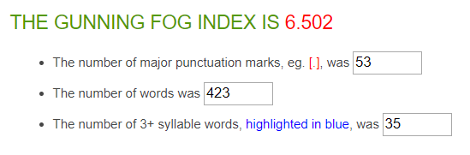

|  |  |
| --- | --- |
| Average Word Length (char) | 4.5 |
| Average Sentence Length (word) | 7 |
| Monosyllabic Words (1 syllable) | 259 |
| Polysyllabic Words (≥3 syllables) | 36 |

**60 sentences in total**

**37 answers in total**

**On average: 1.6 sentences per answer, with a sentence length of 7 words per sentence.**

# **Statistics – Question 3**

### *What do you consider to be commonsense knowledge when vacuuming?*

Go through everywhere.

Put the powercable in the wall outlet. Use the vacuumtool to suck up the dirt. Don't suck things that are too big.

Als je een stofzuiger hebt met meerdere standen kan je de ene stand gebruiken voor bijv. laminaat en de andere voor tapijt.

Don’t forget corners, look if you have a full vacuuming bag.

Which different modes of a vacuüm cleaner serve which function, and how to empty a vacuüm cleaner.

How to turn on the vacuum cleaner and how to vacuum efficiently.

Do not vacuum big materials that are on the floor.

Using the device.

That you need to turn the switch on when you are vacuuming a carpet.

Vacuum under your bed.

Vacuum every corner but do it gently.

Zuig niet te grote dingen op.

The dust is going away when you are vacuuming.

You have to be careful during vacuuming, cause sometimes it takes the little things with it.

Cleaning.

Also vacuum the part which is not visible dirty.

Hoe de stofzuiger werkt.

Eerst alles erom heen dus tafels en banken doen en dan stofzuigen.

How to turn the vacuum cleaner on, how to clean the mess that is on the floor.

Some things are too large to vacuum, for carpets you don't want to use a brush while for 'flat' surfaces you do want to use it.

only collects dust and small garbage, not suitable for sticky objects, liquids etc.

Plug the vacuum in.

Dat je stekker in stopcontact moet steken voordat je begint. Heen en weer bewegen met de stofzuigerbuis en uiteinde op de grond.

To not hoover any liquids and how to change dirt bags.

Stofzuiger aanzetten, stekker in stopcontact steken.

Alles goed schoon stofzuigen.

How a vacuum works and when to renew the vacuum bag.

the floor should be dry before vacuuming.

you need electricity.

you should remove small toys from the floor before vacuum-cleaning.

process to remove dust and other small objects from floor.

uses a vacuum cleaner, requires electricity.

uses air suction.

machine only covers a small area of the room; needs to move around

one or two passes is enough for one spot.

different brushes for flat surface (wood) and bumpy surface (carpet).

Switch device between hard and soft floors.

Vacuuming involves a machine that pulls air through a compartment, trapping the dust and dirt in the air into the compartment. Most vacuum cleaners use a bag for this compartment that will gradually fill up the more vacuuming you do, eventually needing replacement. A vacuum cleaner uses electricity.

You don’t need water for this.

You use a vacuum machine with the sucking part down. At some point you need to clean it otherwise it doesn't suck well anymore.

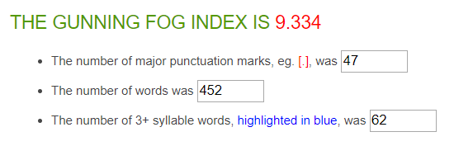

|  |  |
| --- | --- |
| Average Word Length (char) | 4.7 |
| Average Sentence Length (word) | 8.7 |
| Monosyllabic Words (1 syllable) | 278 |
| Polysyllabic Words (≥3 syllables) | 60 |

**52 sentences in total**

**35 answers in total**

**On average: 1.5 sentences per answer, with a sentence length of 8.7 words per sentence.**

# **Statistics – Question 4**

### *What do you consider to be commonsense knowledge when cooking?*

SEASONING (salt and pepper).

Use oil or some kind of fat to make sure the food doesn't stick to the frying pan. Also wash all your food before cooking.

Bij een gasfornuis: eerst gas open en direct vuur aansteken. Als kip gekookt wordt moet het wel een goeie kleur hebben.

Eten opwarmen.

Using the right type of oils/ingredients.

Some basic knowledge about herbs and spices and with which foods they go well, and also knowing how to put together a nutritious meal (carbs, fats, protein and vitamins and minerals).

Wash your food before cooking.

Planned out and multitasking.

1. Do not cook with too much oil, butter, or other sources of fat.

2. Use wooden spoons for certain pans, instead of metal spoons.

Use the pan.

Knowing tot salt your water when you're cooking pasta or potatoes.

Prep your meals first.

What ingredients to use. How to prepare it.

How to handle heat. How to make the basics. How to cut food. What kind of knives are for what.

Zwart is niet goed, pas op ui.

When you want to put something in the oven, the oven first has to be heated.

The pan is hot when it is on the stove. You can't touch the pan, while it is on the stove cooking, because it is hot.

Wash the chicken or meat well.

Use different material when you are preparing meat and vegetables.

Heat the pan before using.

Not burn the food. Cook the chicken until it is free of bacterias and germs.

eten niet aanbranden is belangrijkste.

Always cook chicken, and be careful with anything else that's raw. Dont cut yourself. Dont burn yourself. Watch out for expiration dates. Dont use too much salt or other spices.

you need some form of heat, exposing it to heat to long (usually) burns it.

That it is home tutored.

Not burning the food.

Working with a knife.

How long to cook something. which spices to use. how to separate an egg yolk.

een recept erbij pakken met uitleg en ingrediëntenlijst. je hebt potten pannen nodig en een hittebron.

If taste is bland, consider adding salt. It enhances flavor.

Hand niet in het vuur steken, groente snijden.

Juiste ingrediënten.

you need some food, recipient (pan, pot) and a source of power (gas, electricity).

cooking requires aggregating and transforming the state of some food.

Usage of each type of pan for each cooking.

Best types of cuts for different cooking.

Taste for salt when the food is not boiling.

Fry onions and garlic on a low heat, don't let them brown. Boil water in the kettle before transferring it to a pot. Clean your worksurface as you go.

- hot water hurts your skin.

- Fire burns.

- Cooking can smell badly.

- You need some sort of heat source, if you're preparing a cooked dish.

Careful with hot plates and pans. stir fluid products. watch out for heating too long and too much. use water, oil or butter.

Wash fresh products before cooking.

You should only cook edible things.

you need to the boil water before adding pasta. reduce the gas if it overcooks. cut vegetables with a sharp knife on a wooden/plastic board. removal of certain parts of fruit/vegetables.

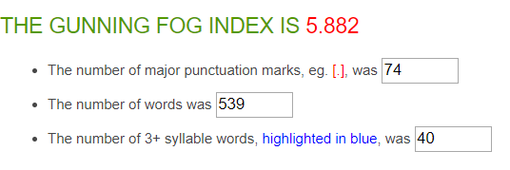

|  |  |
| --- | --- |
| Average Word Length (char) | 4.6 |
| Average Sentence Length (word) | 6.6 |
| Monosyllabic Words (1 syllable) | 351 |
| Polysyllabic Words (≥3 syllables) | 59 |

**81 sentences in total**

**42 answers in total**

**On average: 1.9 sentences per answer, with a sentence length of 6.6 words per sentence.**

# **Statistics – Question 5**

### *What do you consider to be commonsense knowledge when cleaning windows?*

Using detergent.

Use some kind of cleaner. And a soft towel.

Het gebruik van speciale schoonmaakmiddelen voor de ramen.

Ramen natmaken.

Start at the sides and don’t lift the handle untill you reached another side.

No idea.

Don't wash your windows while the air is dusty.

Hot water.

1. Dry the window off after cleaning it.

2. Use the right towels and sponges.

3. Do not clean windows when it is raining (because this is useless).

The movements.

You use water.

Soap.

That thing that looks like a T to het rid of the water and soap.

Starting at the top.

Really get the sides of the window and use warm water.

What kind of products to use. How to actually clean in order to avoid visible lines.

Gebruik zeep.

You need soap and water for cleaning the windows. Also a towel.

First use cleanser then wipe off with something dry.

Geen strepen achter laten.

I don't know.

Use soap and the right equipment like those 'rubber brushes' or a good cloth. Always dry well or you might get soap spots after it dries.

Up to down.

Don't use Sharp objects.

Je hebt een glasreiniger of ander sopje nodig en dat op raam spuiten en iets om het af te nemen.

Knowing when to apply glass cleaner.

Van boven naar beneden schoonmaken om strepen te voorkomen.

Manier van schoonvegen, alles naar een kant vegen.

The general practicalities of it.

there are specific products for cleaning windows.

you need water and soap.

- you should clean them from both sides.

process to remove dirt from windows (the ones humans look through, not the software):

typically uses soap;

typically uses water;

typically done by rubbing the window with soapy water until dirt is gone, then remove access water.

although trivial to automate in isolation, very expensive to automate when windows are part of a building.

Use water, use glass cleaning soap, use whiper for drying.

Cleaning windows is usually done using warm water and some kind of detergent. It improves the clarity of the window, which is the main purpose for cleaning it.

They must be closed otherwise it's dangerous.

You do that when they are dirty. You use water and some tissue at a minimum. Dry them otherwise they get spots.

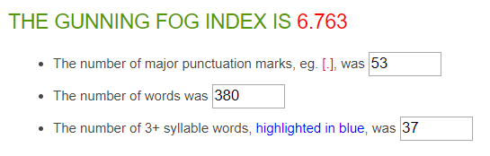

|  |  |
| --- | --- |
| Average Word Length (char) | 4.7 |
| Average Sentence Length (word) | 6.7 |
| Monosyllabic Words (1 syllable) | 216 |
| Polysyllabic Words (≥3 syllables) | 39 |

**57 sentences in total**

**35 answers in total**

**On average: 1.6 sentences per answer, with a sentence length of 6.7 words per sentence.**

# **Average statistics**

### *Average Gunning Fox Index*

(Composed by taking the average of all answers given by students/young adults)

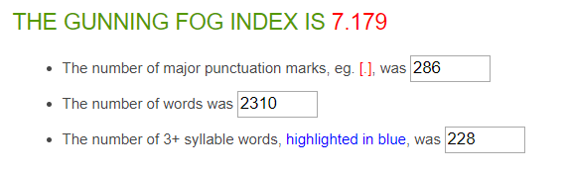

|  |  |
| --- | --- |
| Average Word Length (char) | 4.7 |
| Average Sentence Length (word) | 7.2 |
| Monosyllabic Words (1 syllable) | 1368 |
| Polysyllabic Words (≥3 syllables) | 275 |

**319 sentences in total**

**186 answers in total**

**On average: 1.7 sentences per answer, with a sentence length of 7.2 words per sentence.**